**IDENTIFICATION AND ADDRESSING GENDER BIAS IN CONTENT**

**Project Report Submitted**

**To**

**Gujarat University**

**In partial fulfilment of the requirements for**

**the award to the Degree of**

**5 YEAR INTEGRATED MASTER OF SCIENCE (COMPUTER SCIENCE)**

**SEMESTER – VI**

GUIDED BY: SUBMITTED BY:

**Dr.Hardik Joshi Yadav Ansh Jagdishbhai ( 60027 )**

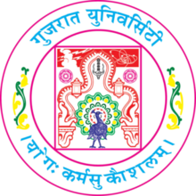

**DEPARTMENT OF COMPUTER SCIENCE**

**GUJARAT UNIVERSITY, AHMEDABAD**

**YEAR: 2023-24**